Assignment 10.2

Name : M.Varsha

Hall.No : 2403A51311

Batch : 13

Task 1 :   
• Write python program as shown below.  
• Use an AI assistant to review and suggest corrections.

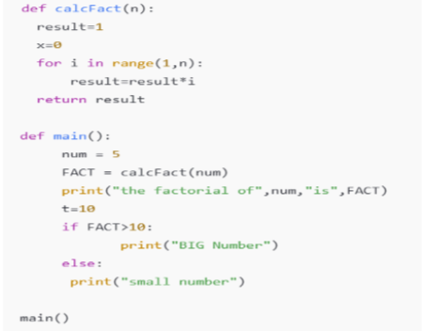  
prompt:

Correct the code

Code and output:

Task 2 :  
• Write the Python code for Fibonacci as shown below and execute.  
• Ask AI to improve variable names, add comments, and apply PEP8 formatting  
(cleaned up).  
• Students evaluate which suggestions improve readability most. one.

Prompt :

Correct the code

Code and output :

Task 3 :  
• Write a Python script with 3–4 functions (e.g., calculator: add, subtract, multiply,  
divide).  
• Incorporate manual docstring in code with NumPy Style  
• Use AI assistance to generate a module-level docstring + individual function  
docstrings.  
• Compare the AI-generated docstring with your manually written one

Prompt :

write a a Python script with multiple functions for a calculator, add manual NumPy-style docstrings, and generate module-level docstrings

code and output :

